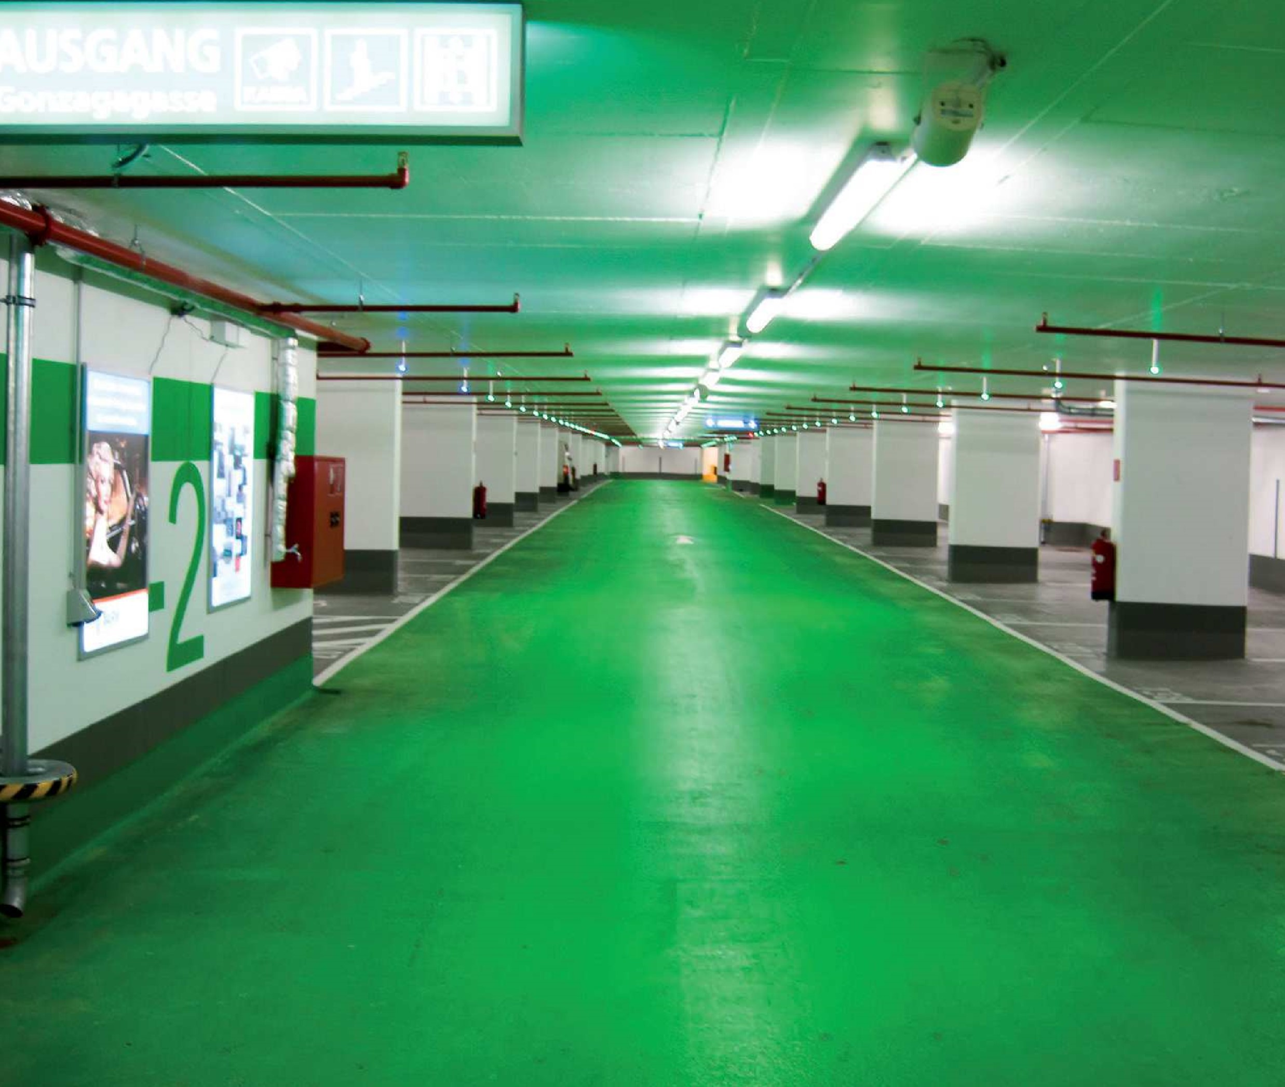

WIPARK Garages GmbH is one of the leading garage operators in Austria.

In total, WIPARK owns and manages 60 parking garages in Vienna. In

August 2014 WIPARK awarded to SKIDATA the contract to equip four

parking garages (Vienna Main Railway Station, B02, and the Manner and

Geriatric Center underground car parks) with cutting edge technology.

SKIDATA took over the complete project management and delivered the

parking solution, together with the entire infrastructure, in a short time.

SKIDATA Installations

Parking Operators

Austria

WIPARK Parking

Garages Vienna

www.skidata.com



Parking Operators

WIPARK Parking Garages Vienna

Austria

Project description

Using newly installed QR barcode readers, a

variety of voucher or payment solutions can

from now on be read, processed, and offered

to customers. And even more: Customers can

book their parking in advance and enter the

garages using the corresponding QR code.

A special comfort is offered to customers

with the integration of the Vienna mobility

card. Annual public transport cardholders

can conveniently use their card to enter

into the car parks and, additionally, are

granted a discount on the parking fee.

In addition to the SKIDATA components, the

entire network technology, including electrical

switch cabinets and UPS systems, was

delivered to the garages. Also delivered was

the entire intercom including emergency

call stations, as well as the ability to transfer

operation of the systems to a master control

center. As the solution partner, SKIDATA was

responsible for the installation, integration

and operational start-up of all systems.

To guarantee optimal maintenance of all four

systems, WIPARK is taking advantage of the

benefits of the SKIDATA.Care Packs for the

next 10 years, with an option for 15 years.

With this service, for example, updates to

the latest software version are automatically

installed, which ensures that WIPARK systems

are always using state of the art technology.

Facts and Figures

Customer

WIPARK Garagen GmbH

Parking Garages

Vienna Main Railway Station, B02, and the Manner and Geriatric

Center underground car parks

Installation Date

September / October 2014

Capacity/Size

in total 1,500 parking spaces

SKIDATA Products

• 12 Power.Gates

• 12 Barrier.Gates

• 6 Power.Cash

• 3 Easy.Cash

• 11 DoorReader.Gates

• SKIDATA.Care Pack

Solution Implemented

Parking.Logic

Requirement

Parking system with cutting edge technology for four parking garages

Realization /

Special Features

• Installation of QR barcode readers in all products for the processing

of reservations, vouchers and payment solutions

• Integration of the Vienna mobility card

www.skidata.com